Python introduction
Python is a high level programming language. It is platform independent and free resource. Python is interpreted language which means code will be executed line by line by this we can easily understand the code and bugs are easily identified.
Anyone can learn python like students,recently graduates,non-technical professionals,career switchesr and hobbysists.
Python is mainly used in data science and AI. In web development also python is used and also in automation and scripting etc.

IDE
Integrated development environment , in this we can write, run and debug the code. All the essential tools will be available in one place it eliminates the need to switch between multiple applications for multiple need.

Python execution flow
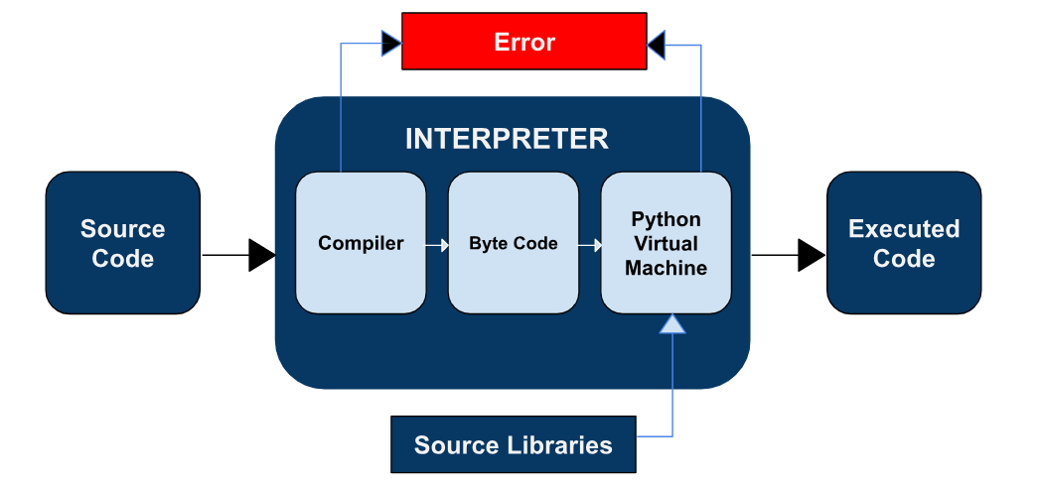
It accelerate the development, catch errors easily, manage complexity.

Python errors:
Syntax errors:
Errors in colons, parentheses.
Logical errors:
Wrong calculation formulas, off-by-one errors in loops. Mainly it happens when the loop runs one time too or one time too few because of an incorrect start value, end value, or loop condition.
Example:loop runs one extra time
For I in range(6):
Print i
Output:
0
1
2
3
4
5
Runtime errors:
Example: division by zero, opening non existing files.
Syntax errors:
Error in code without giving colons, paranthese.
Type error:
For example adding song duration as string “3:45” +5 because we cant add song duration in string.
Name error:
Referencing a variable that doesn’t exist yet.
Example: displaying current song before loading any track into the players play list.
Key error:
Accessing a dictionary key that doesn’t exist.
Key-we cant change
Value- we can change
Source code:
Program written by the programmer to make understandable by computer and convert it into binary code so that computer can execute it.
Compiler languages: c, c++, java.
Global scope: code we can use anywhere.
Local scope: code within the braces means only within the functions.
Primitive data types: which means it has fixed size.
Int, float, double, Boolean, char, complex data types(int+characters like 2j+5) these all are primitive data types.
Non primitive data types:
List, set, tuple, dictionary, string. These all are non primitive data types. These are contigeous memory which means continue memory.
The main difference between tupple and list is ,
Mutable – we can modify
Immutable – we cant modify but when we want change it creates a duplicate .
Command append is used to add variables.
Type function:
It is a built in function used to find the data type of a value or variable.
Example: num=10
Print(type(num))
<class’int’>

